Go to navigate


Scroll down and go to tools
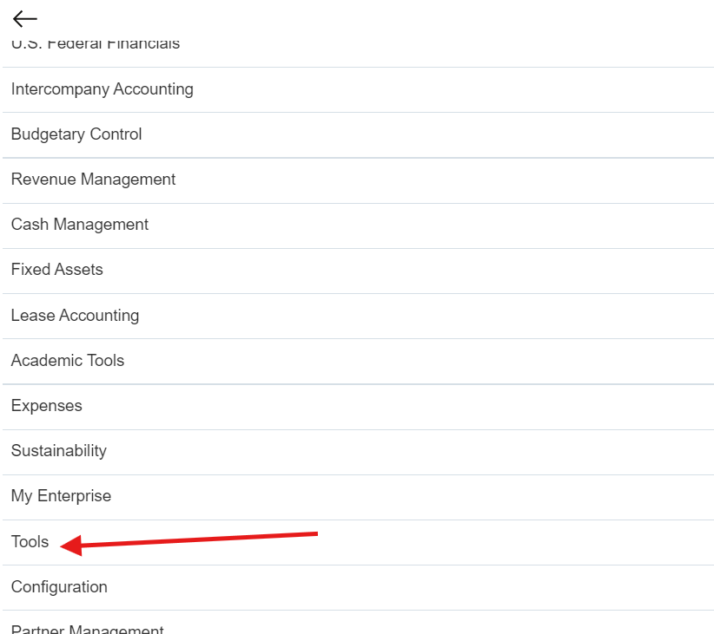

Choose security consol
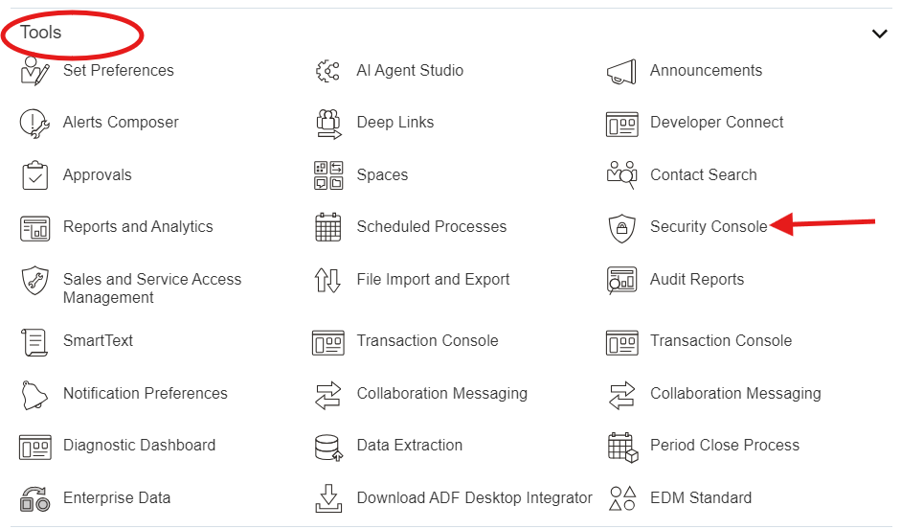
Choose users
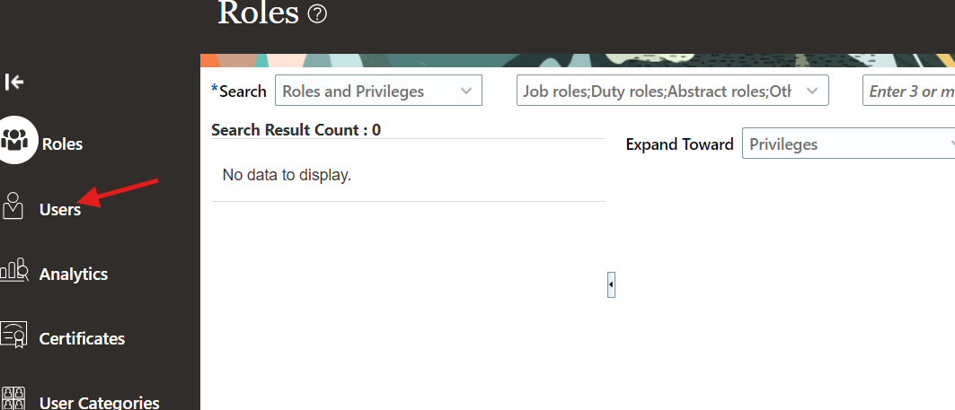
Press on add user button
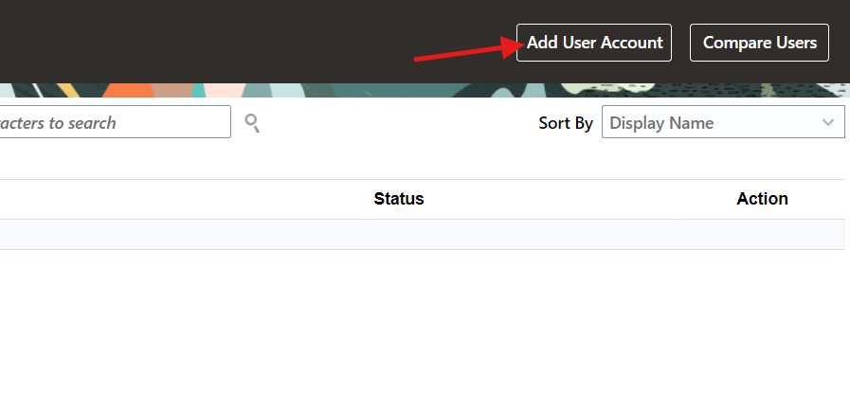
Start to add user data (first name - last name – password) username will be created automatically then add roles.
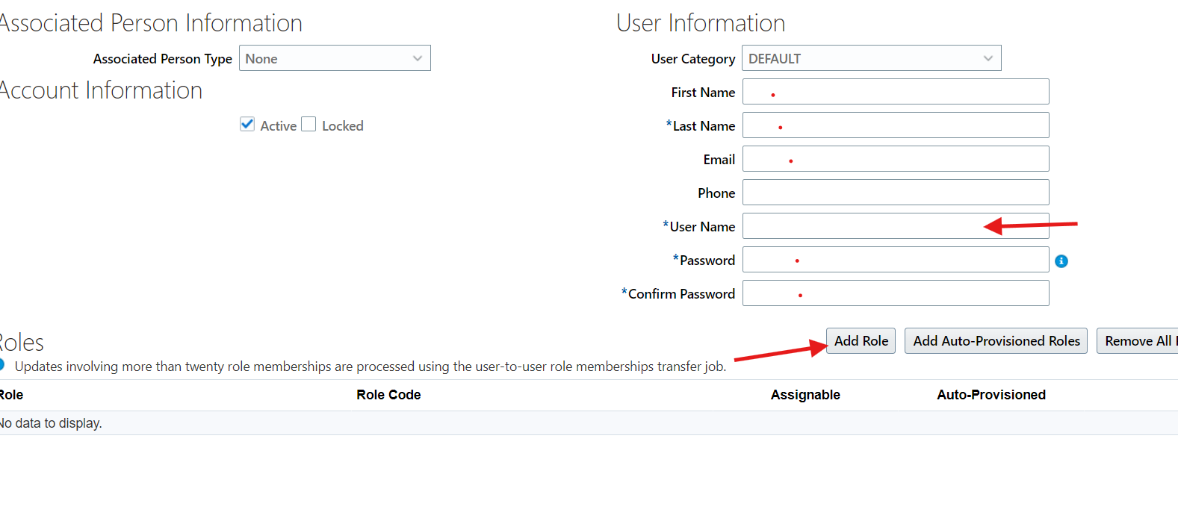

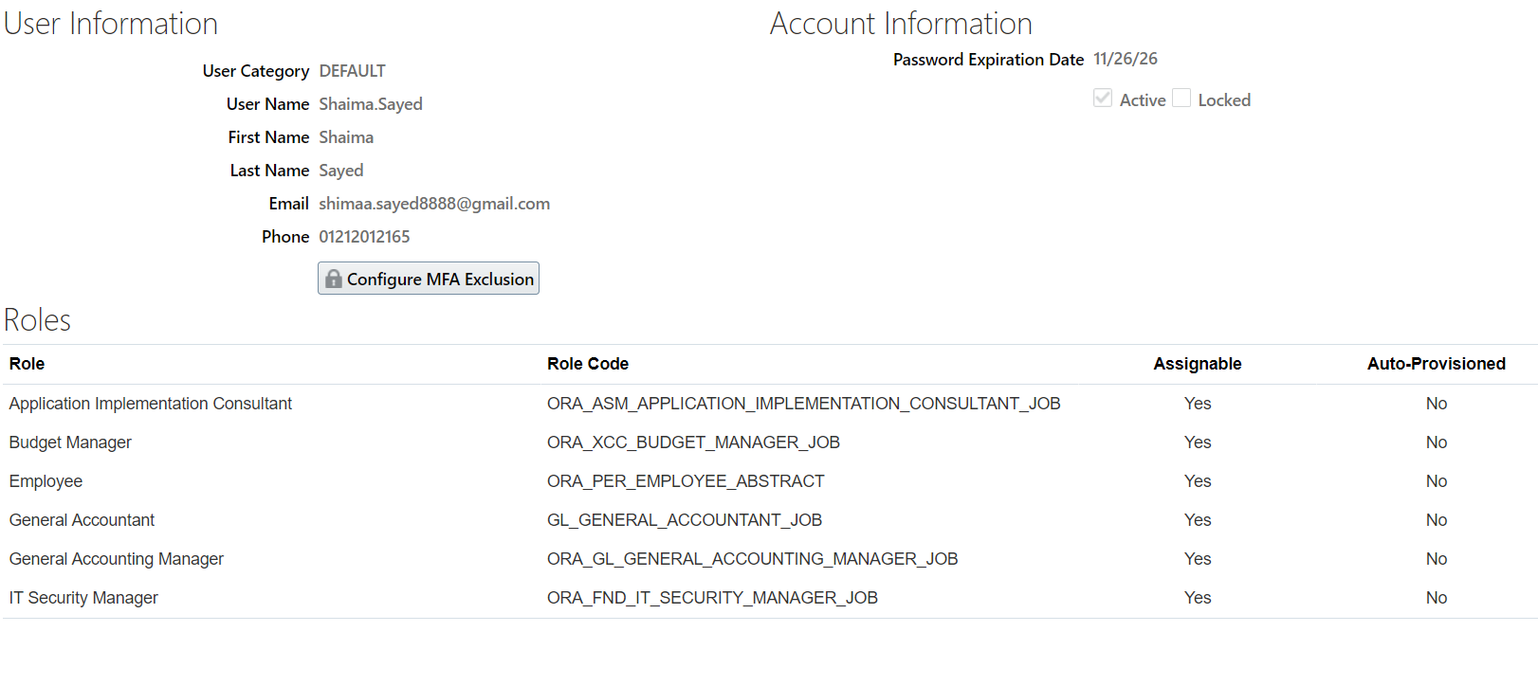
Then you can open your user and start setting up a new project
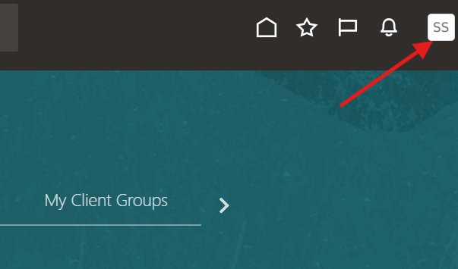
Press on logo and from the list choose setup and maintenance
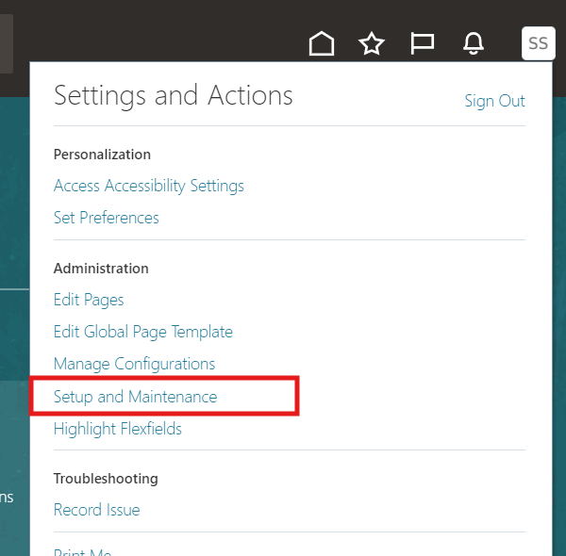
Change setup offering from this button
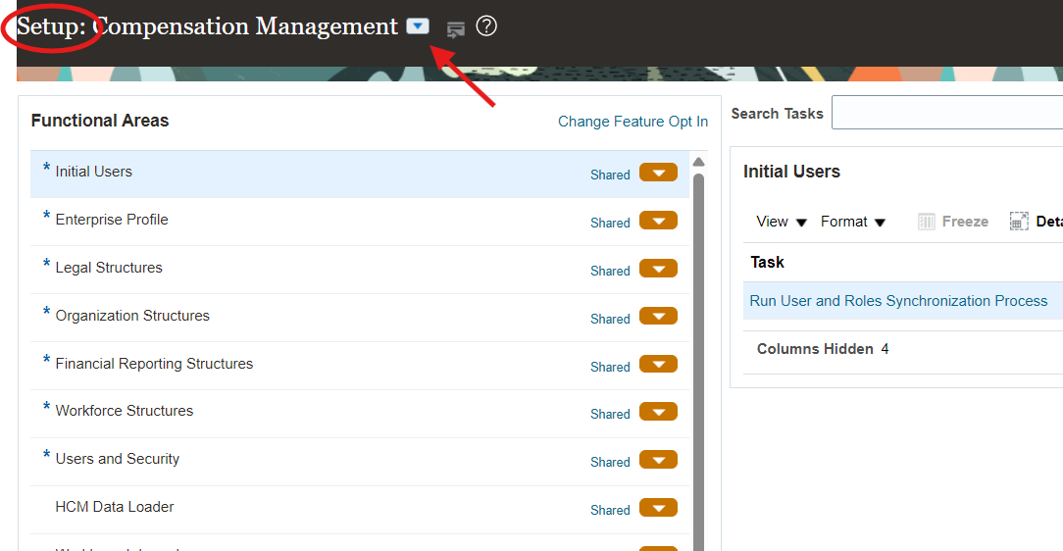

Choose financials
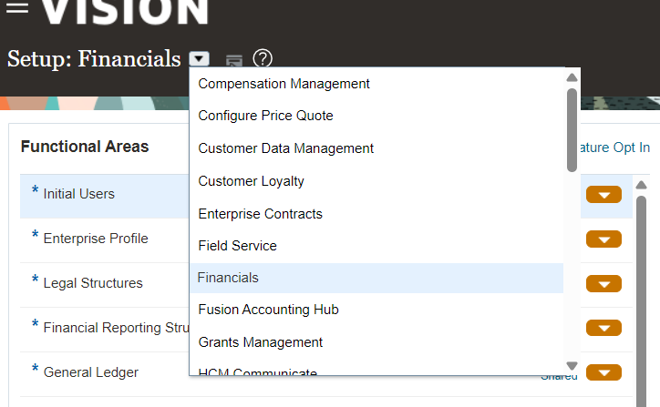

Press on the button on right to open task list
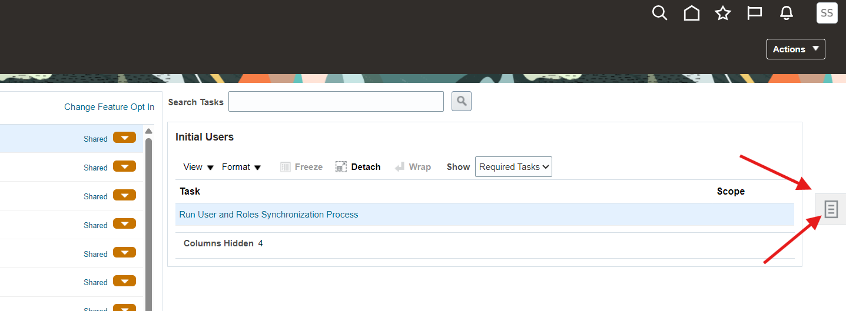
Choose manage implementation projects
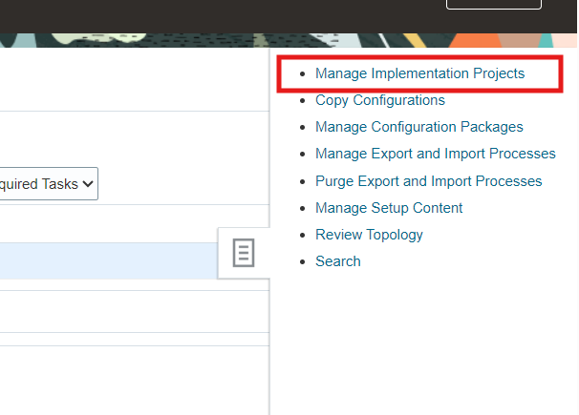
Start creating new project
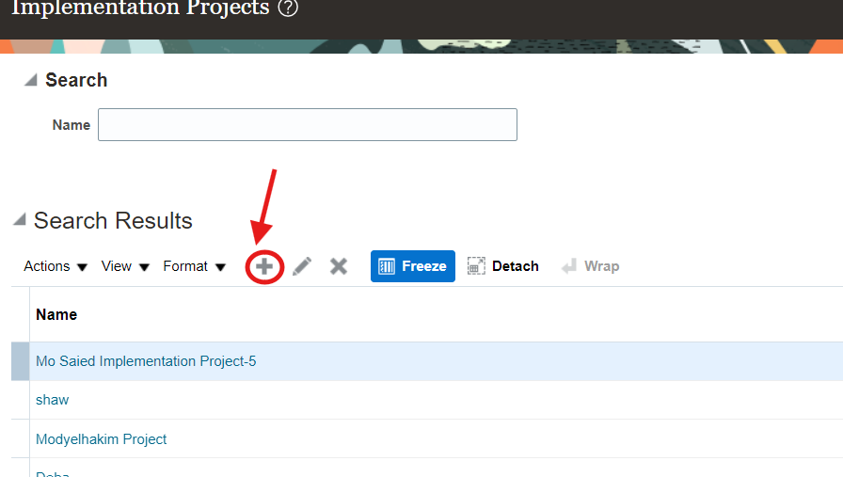
You can change name and the project code will be changed automatically
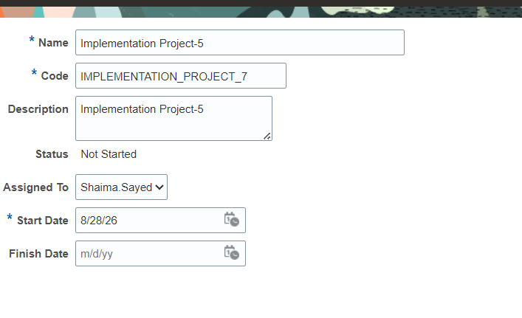

Then press on next button
Then select financial folder and subfolders
Select it one by one in order you will notice that subfolder open automatically, continue selecting it by order until you get to lease accounting option then stop.

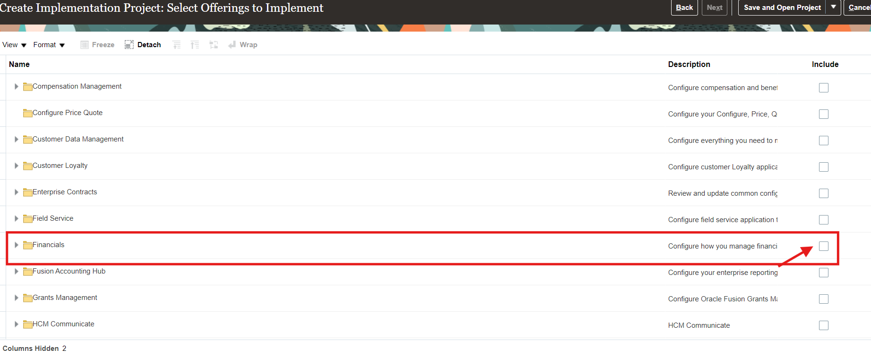

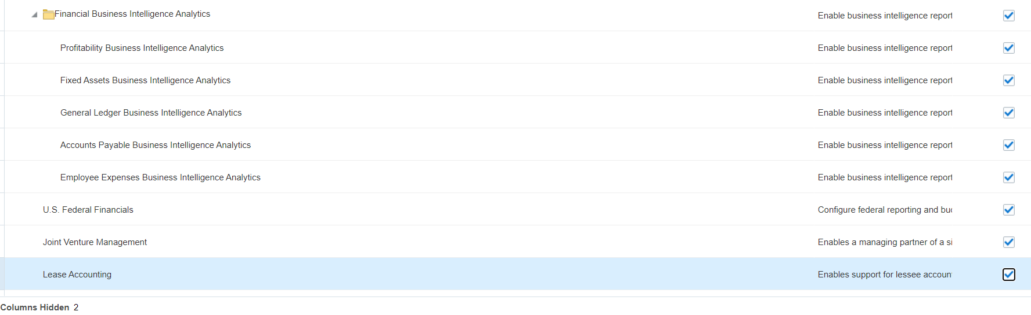

Then press on save and open project button
It maybe takes some time

Press on + button
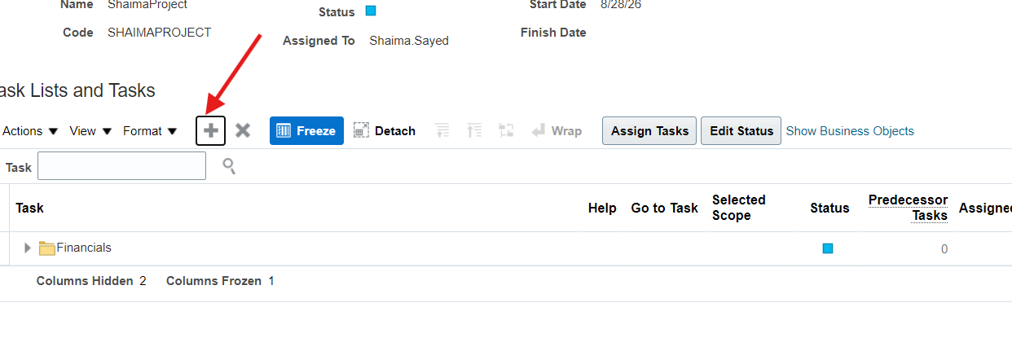
Change from offering to tasklist
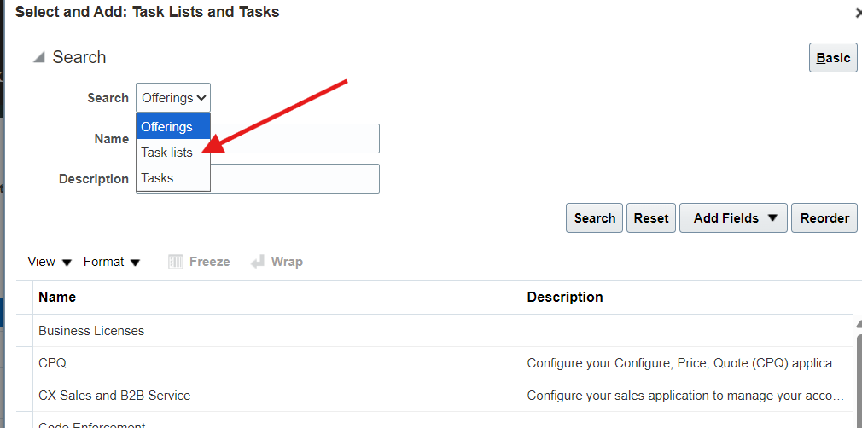
Then search about the word %Rapid% and choose Define common financial configuration for rapid implementation
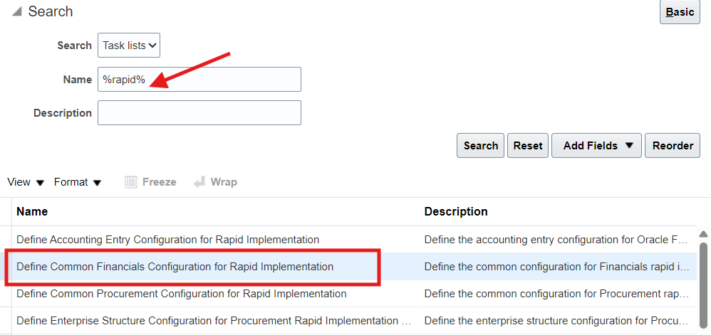
Then press Apply button
Then under option Define common configuration for rapid implementation choose Create chart of accounts… it will download Excel sheet named “RapidImplementationForGeneralLedger” that you can open it and edit with all information related to create ledger and chart of accounts.
In the excel sheet :
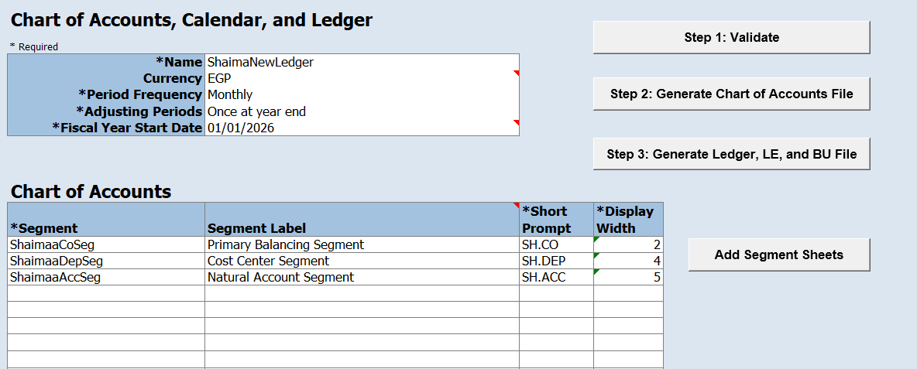
Write the ledger name and select currency, period frequency, adjusting periods and start date of fiscal year.
Then write the segments of chart of accounts.
Add the name and legal entity of your Business unit
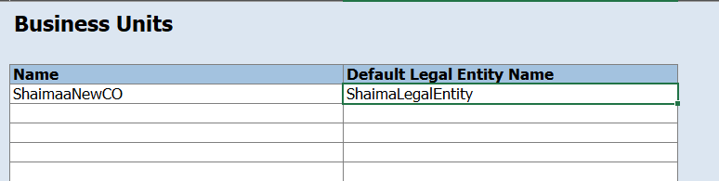

Define companies and all companies as a parent
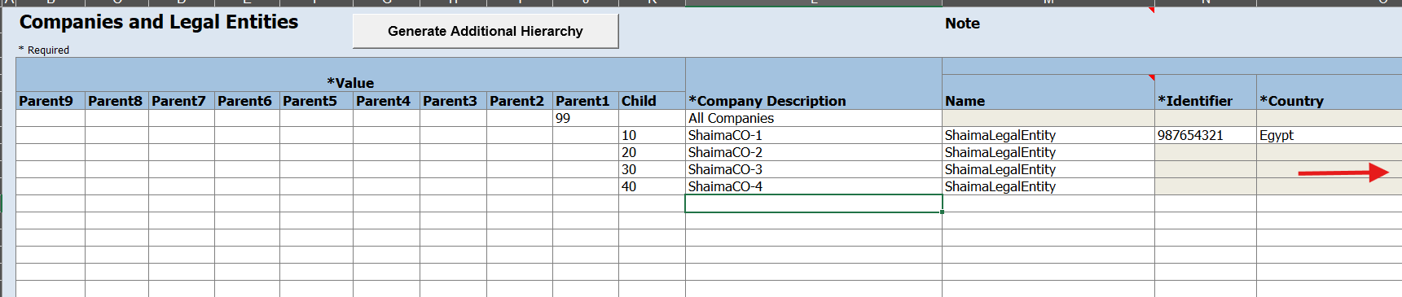
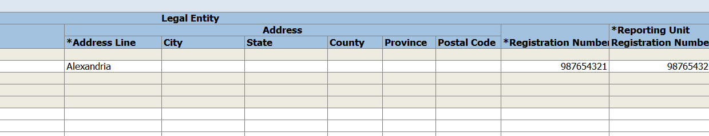
Build chart of accounts
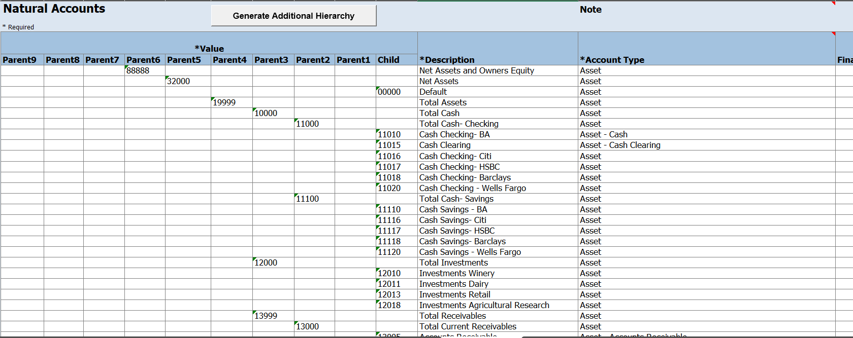
You can use the sample provided in the Instructions sheet from Oracle
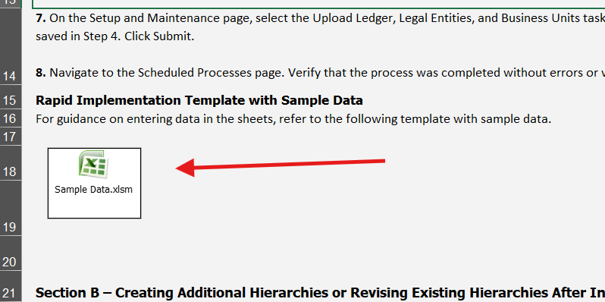
Add sequencies
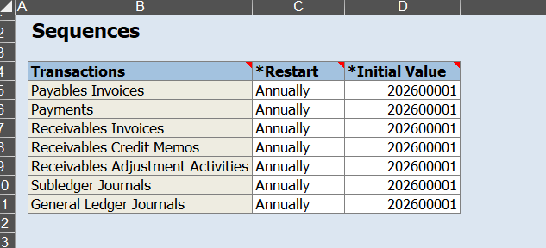
Go back to “COA, Calendar, and Ledger “sheet and press on “Add Segment Sheets” button it will create an additional sheet to define departments under segments
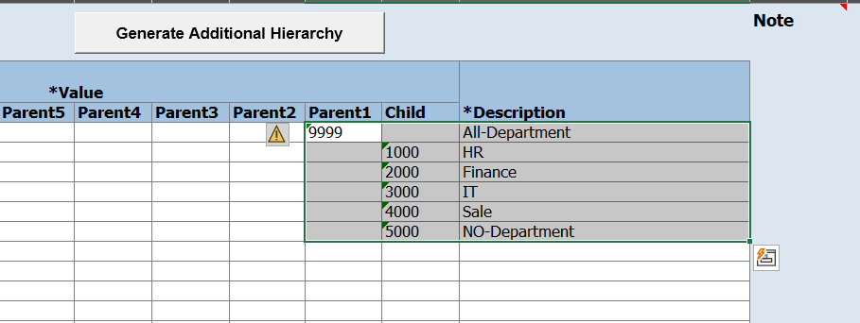
Define all departments and All departments as a parent.
Then go back to “COA, Calendar, and Ledger “sheet and press on “Validate” button
After validating finished press on step 2 and step 3 buttons everyone will create a compressed folder that you will upload on oracle cloud

Go back to oracle cloud and press the button In front of “upload chart of accounts” option
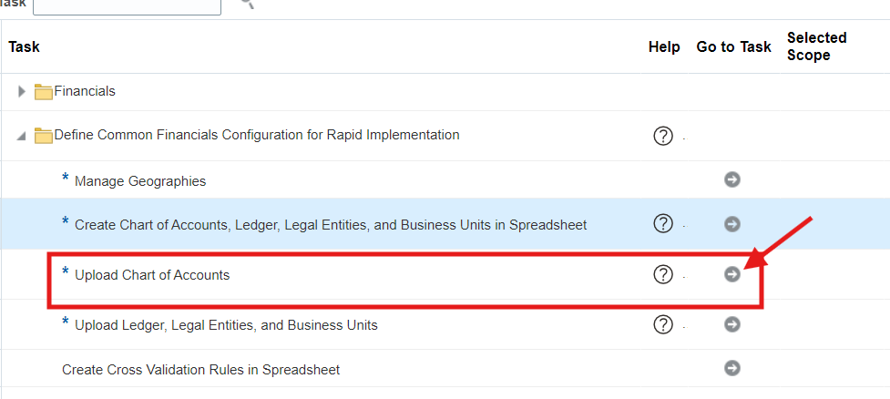
Choose the compressed folder” ChartOfAccounts” from step 2
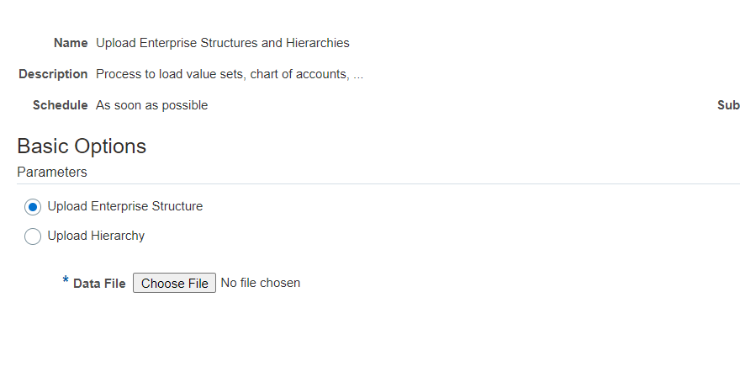
Then click on submit button
It will create a new process and you should make sure that it is successful.
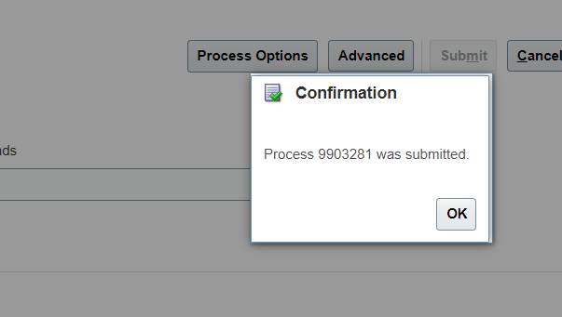
From navigation, tools, schedule processes
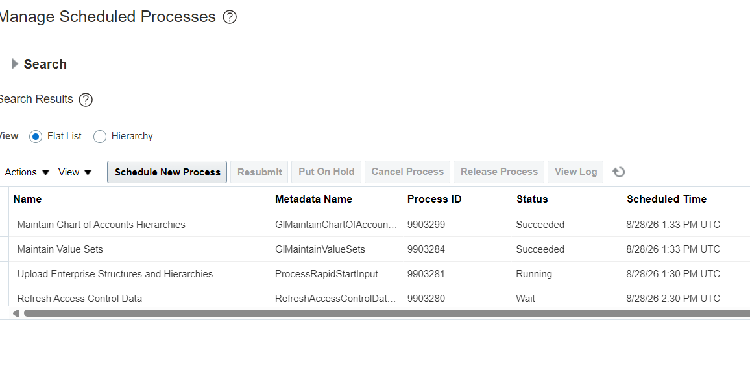
It will take some time until it becomes successful then you can go and upload the other compressed folder “FinancialsCommonEntities” from step 3
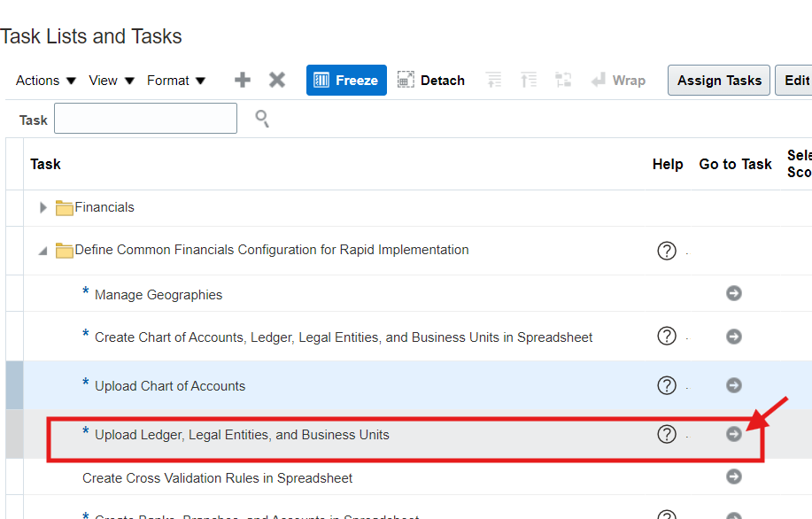

After finishing upload go to setup and maintenance – financial and choose legal structure frome the side menu then choose manage legal entity, press on Select
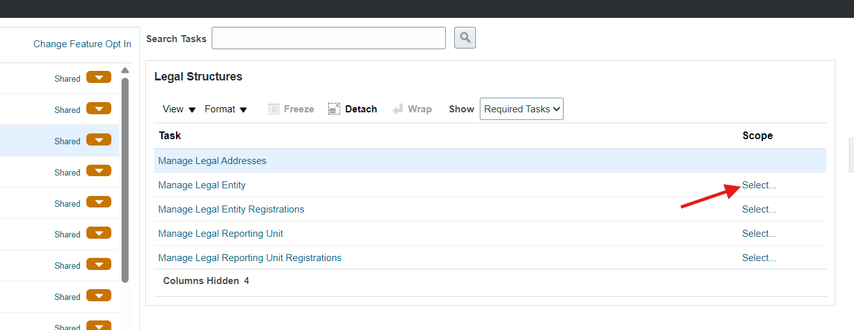
it will open a small window to choose Select and add
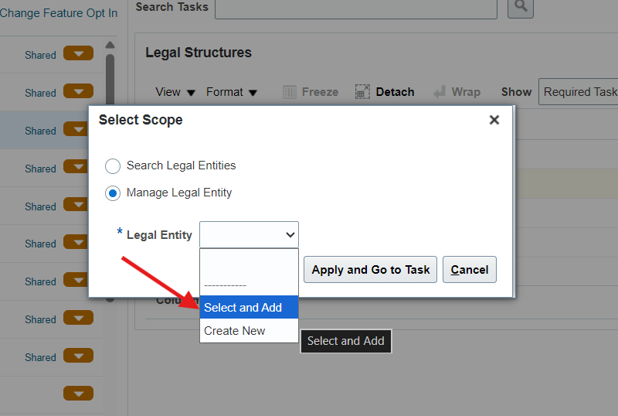

then press Apply and go to task then search about your legal entity, select it finally press on Save and close
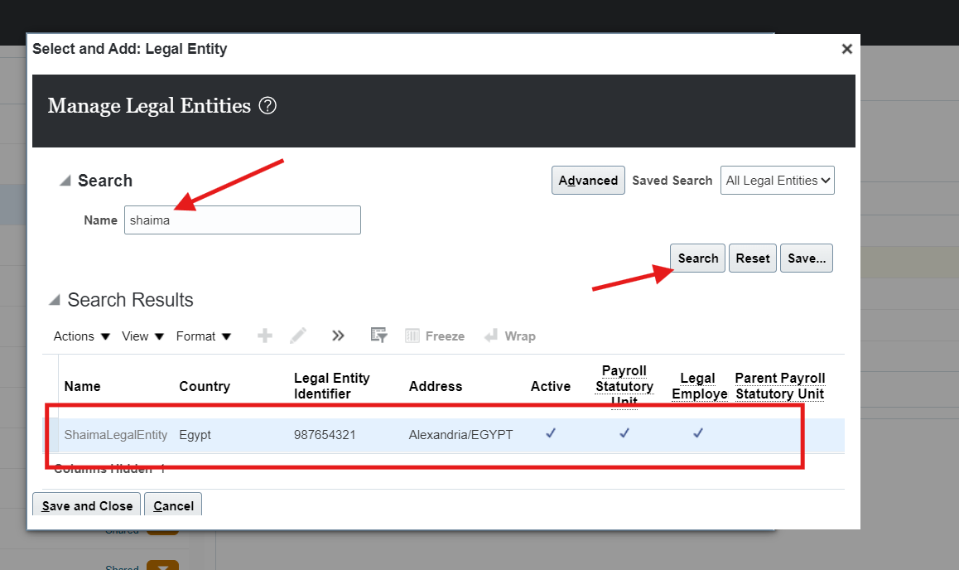
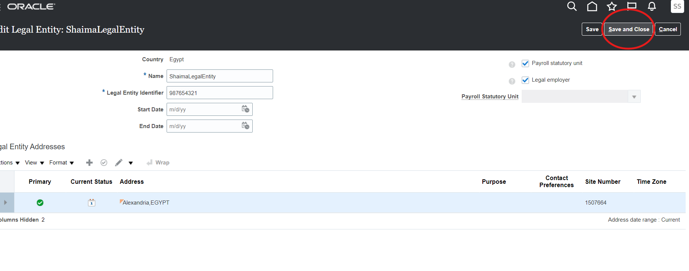
Then go to general ledger option from side menu and choose specify ledger options then press on select and from the small window choose select and add then apply and go to task after that search about your ledger name and select it finally save and close

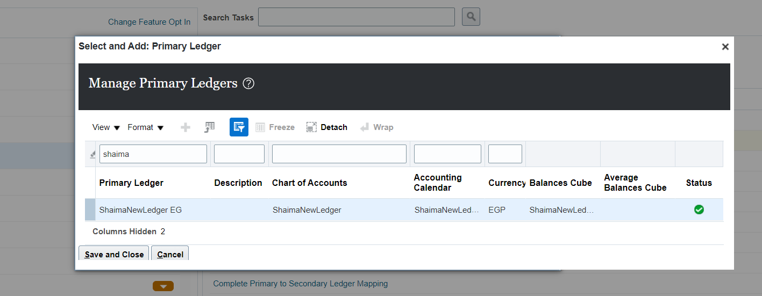

Look for your general ledger settings

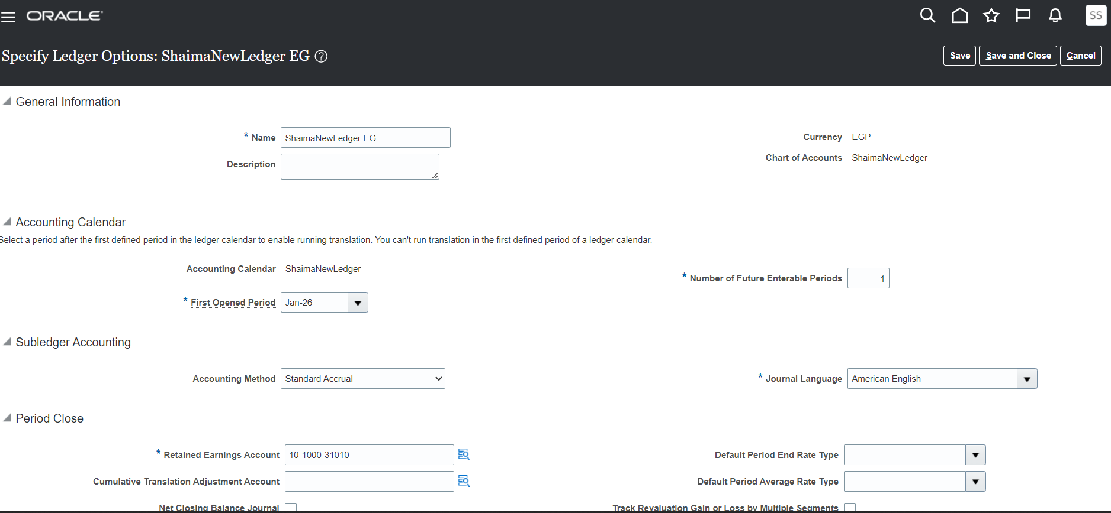

Activate and choose suspense account
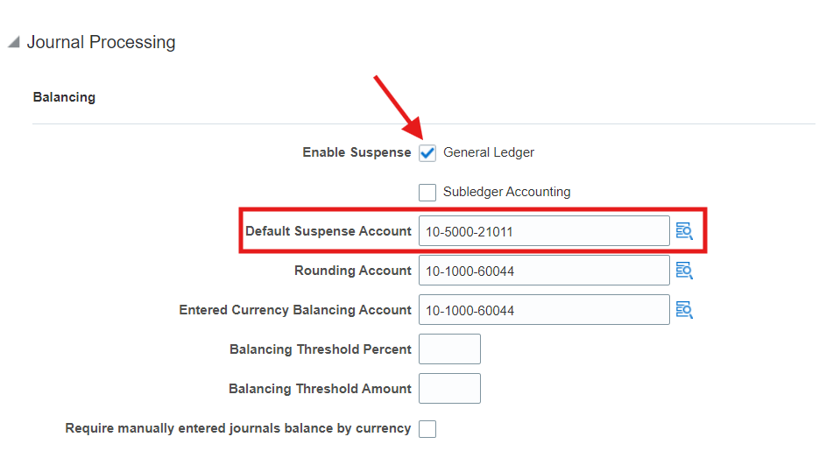

Then press save and close
Back to general ledger option from side menu then choose manage data access set data access for users
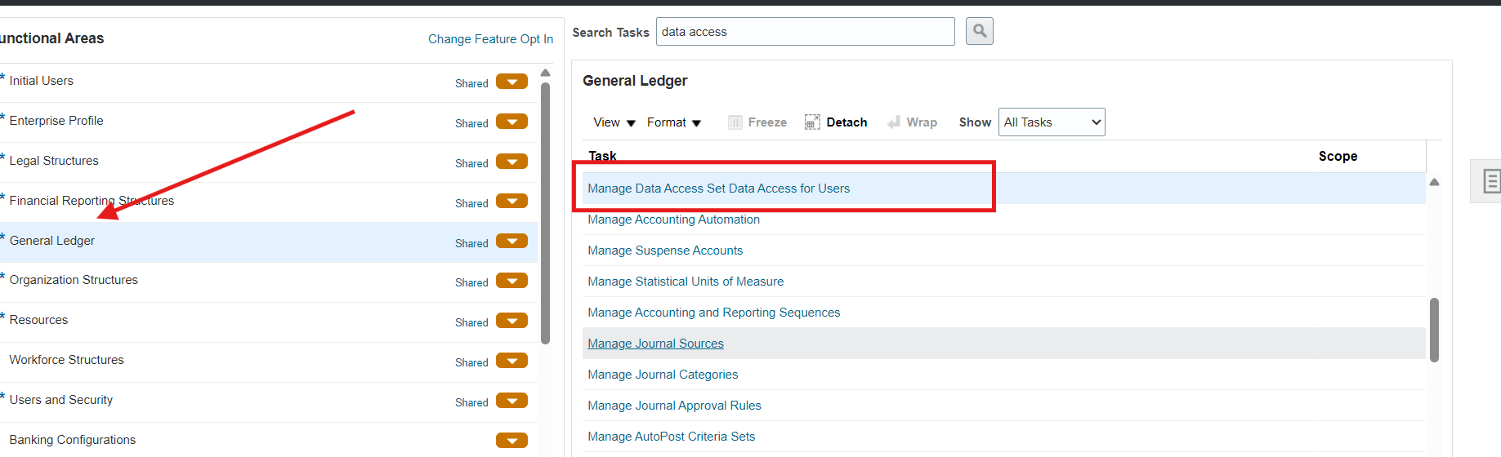

Then press on + button and select your user and ”general accounting manager” role and data access set under security context and your ledger name under security context value
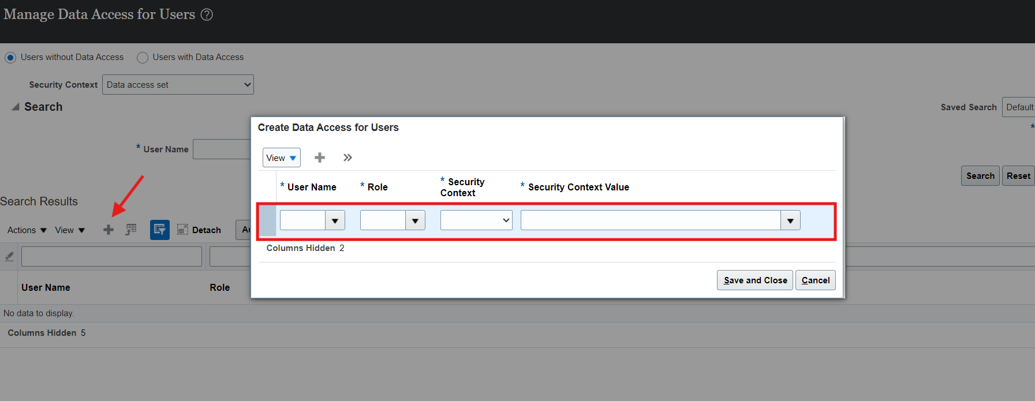
Then save and close then press on Done button in the right top of next page

After that go to open first period
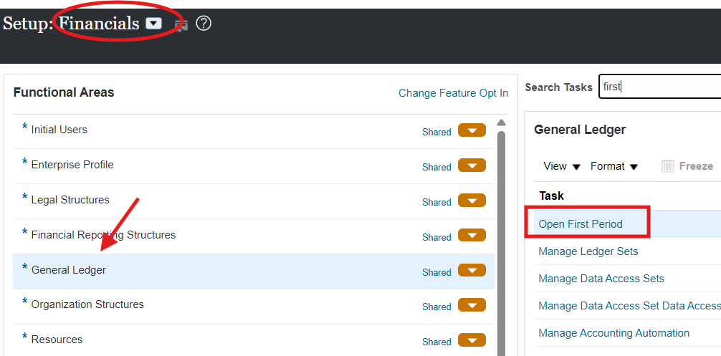

Review your information and submit it
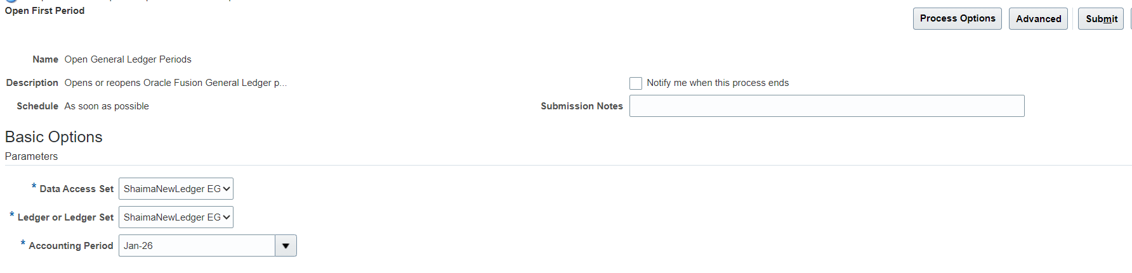

Go to general accounting from home and press on period close button
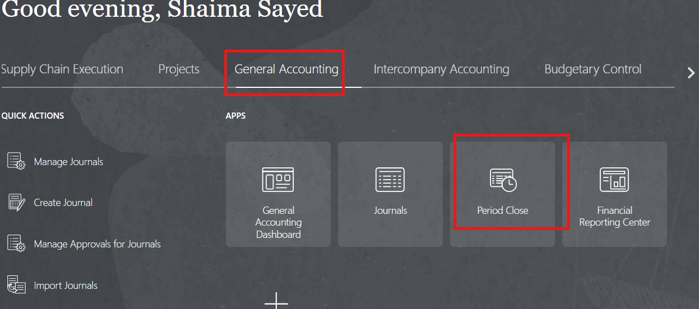
then press on general ledger
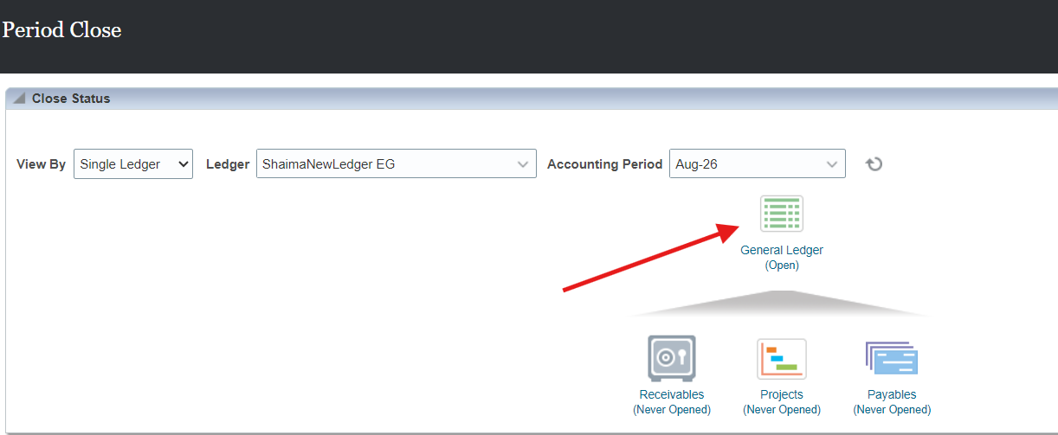

after that you can see all period select the one you need and open it
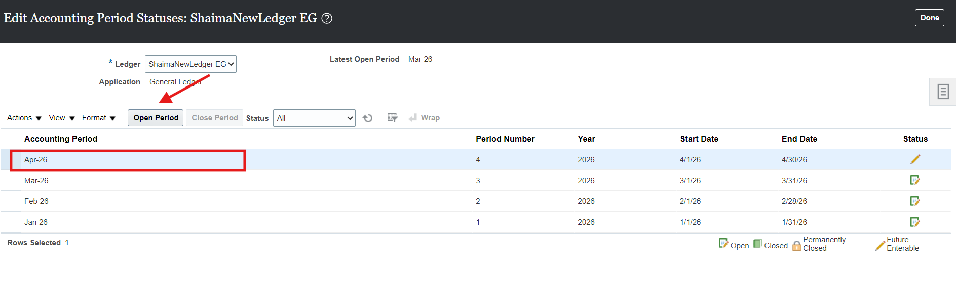
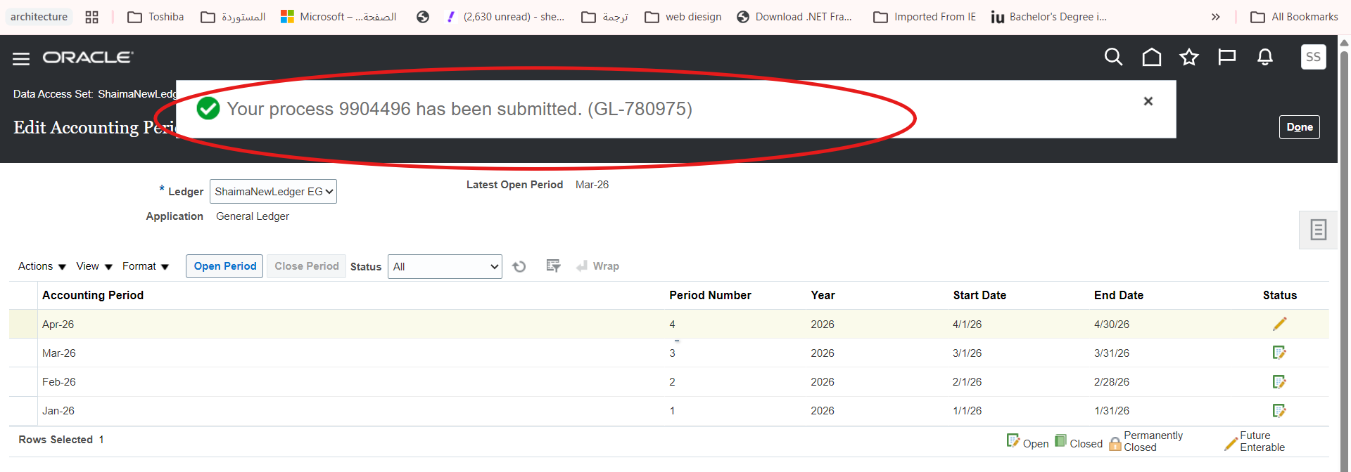

Then you can start create journals
